**THE ARCHIVAL ALCHEMIST: TRANSFORMING CAPSTONE**

**INTO DISCOVERABLE KNOWLEDGE**

A Final Project Presented to the Faculty of

College of Computer, Information and Communications Technology

Cebu Technological University - Main Campus

In Partial Fulfillment

Of the Requirements for Professional Elective 4

By

Jeylsie A. Caro

Kyla A. Hubahib

Maria Carmel A. Tabada

David Jhonson M. Basnillo

Narcisan S. Galamiton, Ph.D.

Adviser

September 2024

## Objectives of the Study

The primary objective of this study is to develop a comprehensive capstone repository system tailored specifically for universities in Cebu that offer capstone courses. This overarching goal includes the following specific objectives:

1. Create an accessible platform: Develop a user-friendly platform that students from various campuses can easily access.
2. Create a centralized repository: Improve the overall capstone project experience for students by providing a centralized repository for showcasing and preserving their academic achievements such as capstone manuscripts for all to explore.
3. Facilitate collaboration and knowledge exchange: Promote collaboration and knowledge exchange among students and faculty across different universities, enabling a wider dissemination of ideas, and innovations in capstone manuscript projects.

## Functional Decomposition Diagram

The figure below illustrates the functional decomposition diagram of the proposed system within the application. It displays the various tasks users can perform within the application.

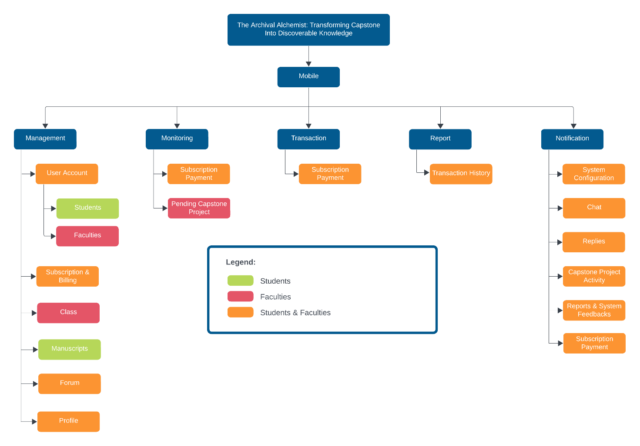

**Entity Relationship Diagram**

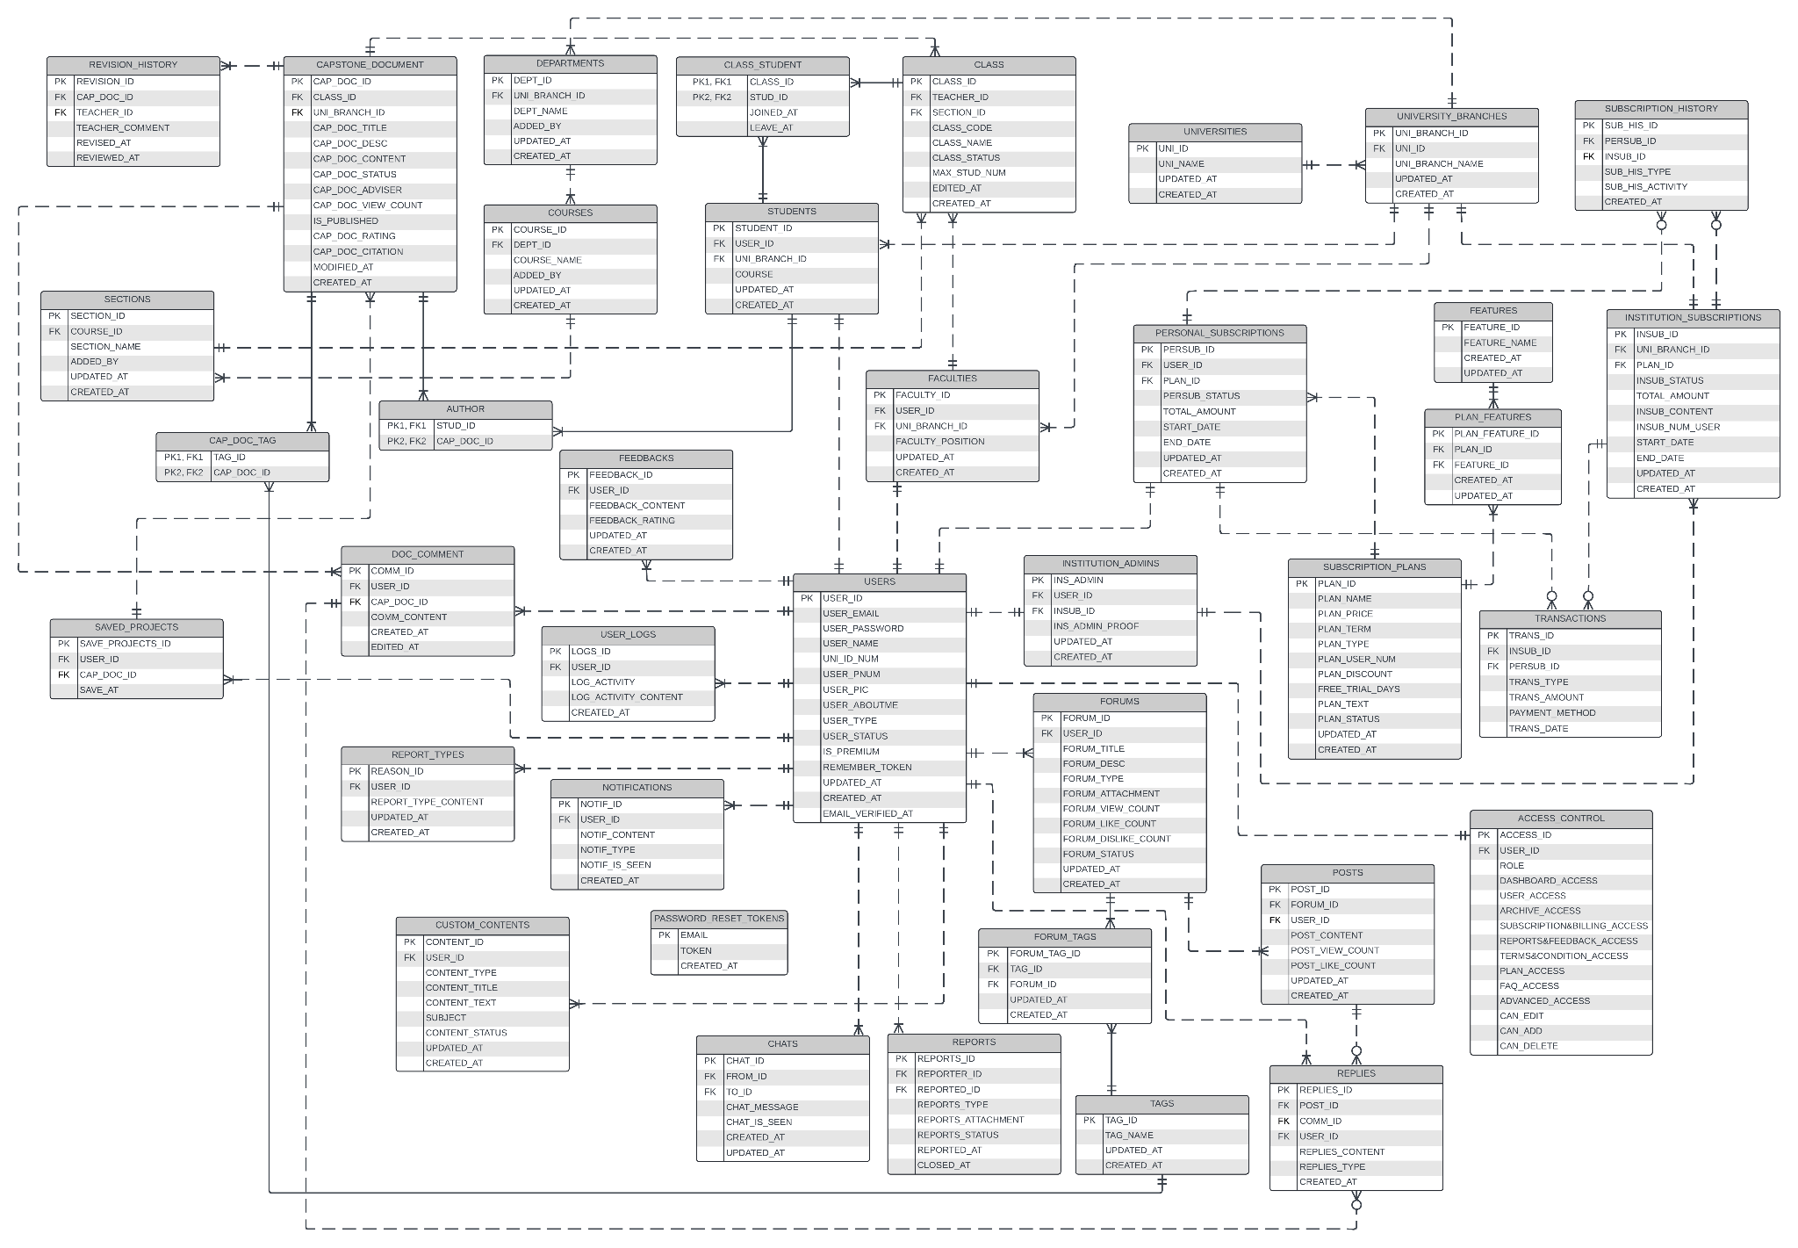

**List of Modules**

|  |  |  |  |
| --- | --- | --- | --- |
| Programmers | Module | Student | Faculty |
| Jeylsie Caro  Kyla Hubahib | **Account Management** | | |
| 1. Register and login | * | * |
| 2. Profile Management | * | * |
| 3. Change Password | * | * |
| Jeylsie Caro  Kyla Hubahib | **Document Management** | | |
| 1. Download projects | * | * |
| 2. Upload and modify capstone projects | * |  |
| 3. Save favorite Projects | * | * |
| 4. Rate Projects | * | * |
| 5. Review capstone projects |  | * |
| Jeylsie Caro  David Jhonson Basnillo | **Client Search and Discovery** | | |
| 1. Search and browse projects | * | * |
| 2. Filter projects such as title, university, author, or tags | * | * |
| Maria Carmel Tabada  David Jhonson Basnillo | **Notifications** | | |
| 1. View Notifications | * | * |
| 2.Delete Notifications | * | * |
| Maria Carmel Tabada  David Jhonson Basnillo | **Forum** |  |  |
| 1. Search and browse discussions | * | * |
| 2. Filter discussions such as title, author, or tags | * | * |
| 3. Posting | * | * |
| 4. Commenting | * | * |
| 5. Report post | * | * |
| Maria Carmel Tabada | **Chat** | | |
| 1. Send or Receive Message | * | * |
|  | **Subscription** | | |
| Kyla Hubahib | 1. Purchase and renew Subscription | * | * |
| 2. Cancel Subscription | * | * |
| No of Points (1 per module per user) | |  |  |
| Number of Modules per User (equals no.of points per user) | |  |  |
| Total Number of Modules | |  |  |